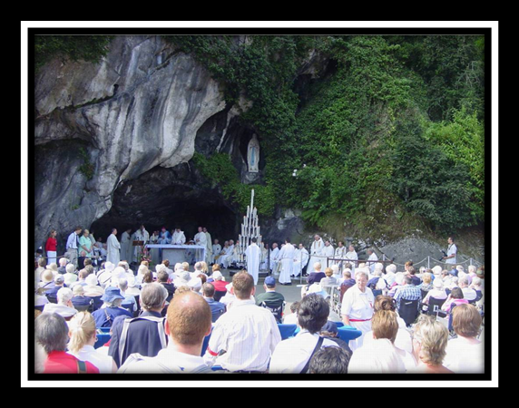

TASK:
Design a brochure for Christians visiting Lourdes, Taizé or the Holy Land

Using your classwork on pilgrimage and your own independent research you need to design an interesting brochure that will:

- Encourage Christians to visit either Lourdes, Taizé or the Holy Land on pilgrimage
- Explain what a pilgrimage is
- Identify, describe and explain the key beliefs and practices (activities) that Christians will take part in whilst on this pilgrimage.

Think about:

- What is a good definition of pilgrimage?
- Why is pilgrimage important to Christians?
- Why is the place you have chosen a good destination for a pilgrimage – particularly for Catholic Christians?
- Describe the history of the place – why is it a place of pilgrimage today?
- Describe and explain what a pilgrim can do there
- Include pictures and interesting facts

Remember,
  - use your class work
  - show independent research (don’t copy and paste from the internet!)
  - add pictures and present it clearly with sub-headings and sections
  - show a range of RE key skills – DESCRIBE and EXPLAIN
  - show how a Christian’s belief is linked to what they do in their lives
  - Take pride in the way that you set out your work
  - Meet the deadline set by your teacher
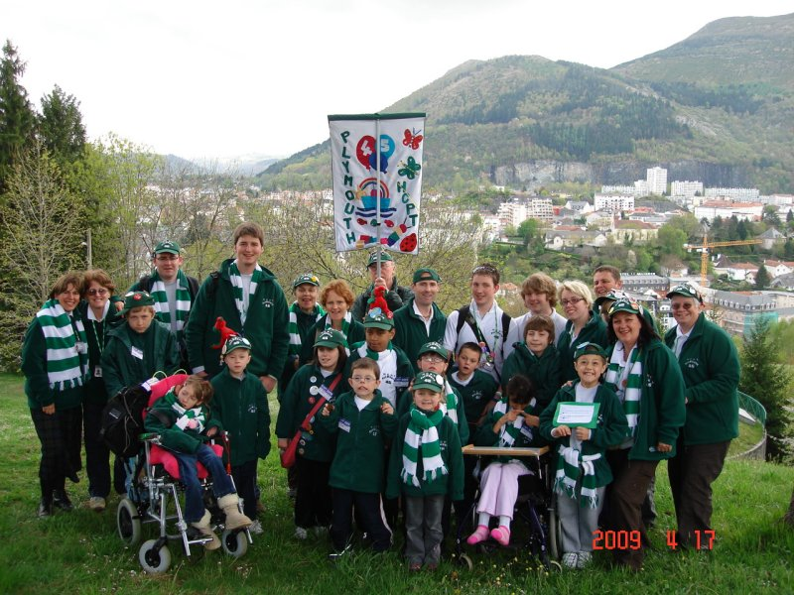
  - Good luck and have fun!

